**Ewing Christian College**

(An Autonomous College of Allahabad University)



A

Project Report

On

**“LIFEcure Clinic Management System”**

Submitted to **“EWING CHRISTIAN COLLEGE”**

In the Partial fulfilment of requirements for award of the Degree of

Bachelor of Computer Application

2022-2023

**Submitted By,** **Under the Guidance of,**

* Trishita Kesarwani(413003) Er. Abhishek Srivastava
* Chourasiya Rahul(413004)

**CERTIFICATE**

This is to certify that the project entitled **“LIFEcure Clinic Management System”** is a record of project work done by **Trishita Kesarwani(413003)** and **Chourasiya Rahul(413004),** B.C.A final year student in the partial fulfilment of the requirement for the award of degree of Bachelor of Computer Application, Ewing Christian College, Prayagraj.

Project Guide Signature

**Er. Abhishek Srivastava**

**___________________**

**ACKNOWLEDGEMENT**

We would like to express special thanks of gratitude to my guide **Er. Abhishek Srivastava** for guiding and correcting our project with attention and care. Without his guidance, this piece of work was a difficult task. We also express our thanks to **Dr. Anil Kr. Singh,** co-ordinator of BCA department.

Last but not least, we would also like to thanks to all teachers, friends and family members who have helped directly or indirectly in every means to complete this project.

**Trishita kesarwani (413003)**

**Chourasiya Rahul (413004)**

**PREFACE**

Today we all are residing in computer area and computers have become an integral part of our society which has completely revolutionized the life cycle and pace of society. It has given us an ultimate tool to get work faster and easier in our day-to-day life in every field.

First of all acknowledgement for respected teachers and friends is given, who helped us very much in developing the project. Then the next topic is the introduction of the project. Then the need of our software is discussed. The feasibility study is done in various areas, before developing the project. The next topic shows the tools, platform and language used in the project.

**TABLE OF CONTENT**

**PAGE NO.**

**1.** Introduction….…………………………………………………. 6

**2.** Objective of the project...………………………………………. 7

**3.** Synopsis of the project ……..………………………………….. 8

**4.** Features of the project …...…………………………………….. 9

**5.** Analysis…….………………………………………………….. 10-11

**6.** About HTML…………………………………………………... 12-13

**7.** About CSS..……………………………………………………. 14

**8.** About JavaScript ………………………………………………. 15

**9.** Technology and platform used ………………………………… 16

**10.** Methodology used …………………………………………… 17

**11.** System design ……………………………………………….. 18

**12.** Testing……………………………………………………….. 19-20

**13.**Screenshots and coding………………………………………... 21-42

**14.** Future Scope…………………………………………………. 43

**15.** Conclusion…………………………………………………… 44

**16.** Bibliography…………………………………………………. 45

**INTRODUCTION**

In the era of technology, where everything needs to be done efficiently and effectively, the existence of Clinic Management System has become necessary. Nowadays, Clinics have become popular within the patients having minor ailments and for certain specialities. Thus, The use of Clinic Management System can enhance the services and also the work flow of all activity that happens in the clinic where it helps in reducing the workload of staff, the number of man power needed and it also make the clinic become more manageable and easier to control.

The **“LIFEcure Clinic Management System”** is a website designed for a clinic, named as “LIFEcure” which is located at Kanpur and Fatehpur.

This system provides a suit of functionalities that makes easy to manage the clinic. Booking and managing appointments are two main problem faced by the clinic, but this system makes easy to manage the Lifecure clinic located at different locations into a single system with the aim of reducing manual workload of the doctor.

This system will be used to manage patient records and their queries, thus providing faster access of data. All these activities are done routinely and would be cumbersome on the staff if done manually hence need of an efficient and easy to use management system is required that will ease the workload on doctor in the clinic.

Currently, there is a huge number of hospitals/clinics that keep their patients records in books and store them manually. It is a very common way of storing records but storing data in this manner may lead to loss and redundancy of data with no security and backup facilities. Applying this Clinic management system will help manage these records and preserve the information for longer periods of time and also make its access far much simpler and easier, it also ensures accuracy and openness of the patient’s records. This system also inspire other clinics to use a digital system rather than manual book for their work.

**OBJECTIVE OF THE PROJECT**

The main objective of this project is to increase reach of LIFEcure homeopathic clinic among the patients. This project has been developed to reduce the manual efforts of both patients and doctors and make other work easier and efficient.

It aims to give complete facilities to the patients and doctors. The patients can easily book their appointments anytime from anywhere.

The patients can consult to their doctor digitally and easily get opinion at their homes. As a result, it will reduce the manual workload, errors, operational costs and provide easier access.

**SYNOPSIS OF THE PROJECT**

In homeopathic clinics, Doctors maintain record of each patient manually for their further treatment due to which they have to manage huge records of patients manually. Maintaining appointments schedules was a herculean task at the clinics involving various functional ineffiencies.

Also, Patients at remote locations face certain limitations for registering their appointments. In manual way, they have to reach the clinic within the doctor’s serving time to get treated.

This particular topic is chosen by us for reducing all the efforts faced by patients and doctors. Also as a Student, we want to explore new ideas and opportunities so we have chosen a live project which is for a homeopathic clinic. This project will help us to enhance our skills and ability to develop real life experience. It also develop an ability to tackle various challenges.

**Advantages of project-**

* It is a medium for the interaction of doctors and patients.
* Easy to use, efficient and user friendly environment.

**Disadvantages of project-**

* We should not able to resize the window.
* This system will only beneficial for those who know about the internet.
* Button doesn’t work on click, as it is a static website.

**FEATURES OF THE PROJECT**

This project has following features -

* The user and admin can navigate the website easily through the menu bar.
* The menu bar consists of Home page, Appointment, Case studies, Contact us and About us.
* The home page consists of a concise overview about the clinic.

There is also a query box at home page which helps user to get opinion of the doctor regarding their diseases.

* Through Appointment page, user can easily book their appointment to the website.
* The Case Studies page consist of all diseases which is cured by the doctor.
* Contact us page has location and contact details of different branches of clinics. User can contact and reach to their nearby clinics with the help of details provided in that page.
* About us gives an introduction about the doctor, their achievements and also about the clinic.

**ANALYSIS**

The LIFEcure Clinic Management system begins with the following activities performed together.

These are the steps of System development Life Cycle used for development of this project-

1. **REQUIREMENTS**

It is the first stage of System Development Cycle. The preliminary investigation must define the scope of the project and perceived constraints, opportunities and directives that triggered the project. As for this project, we collected the system and customer requirements through interviewing the doctor and patients.

The preliminary investigation includes the following tasks-

* Listing problems, opportunities and directives.
* Plan the project.
* Designing the project.

1. **FEASIBILITY STUDY**

The goal of feasibility study is to evaluate the most feasible and desirable system for the development which consist of the following tasks-

* Statement of the problem.
* Summarizing of findings and recommendations.
* Details of findings.
* Recommendations and conclusion.

We addressed three types of feasibility study in our analysis, they include the following types-

* **Operational Feasibility**

During the operational feasibility analysis, we investigate that the operating requirements of the proposed system is feasible or not.

* **Time Feasibility**

Being a small system and given the period of 3 months of development, it is time feasible.

* **Technical Feasibility**

Technical feasibility refers to the ability of the process to take advantage of the current state of the technology in pursuing further improvement. Since it is not a complex system, we have the technical feasibility for developing the system or project.

1. **SYSTEM ANALYSIS**

System analysis is the process of gathering and interpreting facts, diagnosing problems, and using the information to recommend improvements on the system.

Analysis is a problem solving activity that requires intensive communication between the system user and system developer.

System analysis or study is an important phase of any system development process. The system is viewed as a whole, the inputs are identified and the system is subjected to close study to identify the problem areas. The solutions are given as a proposal. The proposal is reviewed on user requests and suitable changes are made. This loop ends as soon as the user is satisfied with the proposal.

1. **DESIGN**

The design phase creates a blueprint for the new system that will satisfy all documented requirements. It identifies all necessary outputs, inputs, interfaces and processes. A Design will ensure:

* Reliability
* Maintainability
* Accuracy

The design is documented if the system’s design specification and presented to the user for their review and approval. The involvement of user is to avoid any misunderstanding about what the system will do and how it will do.

1. **IMPLEMENTATION AND CODING**

In the implementation phase, the new system is constructed by the programmers and designers and finally delivered to final user.

After implementation, data is converted into system files, user is trained, and the actual transition to the new system is undertaken.

The requirements of the user are then actual implemented through coding with the help of languages HTML, CSS and JavaScript.

**ABOUT HTML**

**HTML** stands for HyperText Markup Language. It is used to design web pages using a markup language. HTML is the combination of Hypertext and Markup language. Hypertext defines the link between web pages. A markup language is used to define the text document within the tag which defines the structure of web pages. This language is used to annotate (make notes for the computer) text so that a machine can understand it and manipulate text accordingly. Most markup languages (e.g. HTML) are human-readable. The language uses tags to define what manipulation has to be done on the text.

**Basic elements of HTML**

Using HTML, a text file is further marked up with additional text describing how the document should be displayed. To keep the markup separate from the actual content of the HTML file, there is a special, distinguishing HTML syntax that is used. These special components are known as HTML [tags](https://www.techtarget.com/whatis/definition/tag). The tags can contain name-value pairs known as [attributes](https://www.techtarget.com/whatis/definition/attribute), and a piece of content that is enclosed within a tag is referred to as an HTML element.

HTML elements always have opening tags, content in the middle and closing tags. Attributes can provide additional information about the element and are included in the opening tag. Elements can be described in one of two ways:

1. Block-level elements start on a new line in the document and take up their own space. Examples of these elements include headings and paragraph tags.
2. Inline elements do not start on a new line in the document and only take up necessary space. These elements usually format the contents of block-level elements. Examples of inline elements include hyperlinks and text format tags.

**Pros of HTML:**

* Is widely adopted with a large amount of resources available.
* Is natively run on every browser.
* Is relatively easy to learn.
* Has a clean and consistent source code.
* Is open source and free to use.
* Can be integrated with other backend programming languages [such as PHP](https://www.theserverside.com/blog/Coffee-Talk-Java-News-Stories-and-Opinions/HTML5-PHP-File-Upload-Example-Apache-Server).

**Cons of HTML:**

* Does not have very dynamic functionality and is mainly used for static web pages.
* All components must be created separately even if they use similar elements.
* Browser behavior can be unpredictable. For example, older browsers may not be compatible with newer features.

**ABOUT CSS**

CSS(Cascading Style Sheet) is defined as a method sheet language that provides web designers control over how an internet site communicates with web browsers including the formatting and display of their HTML documents.CSS or cascading sheet may be a text-based coding language that specifies the website formats and the way a site communicates with web browsers. The language allows web developers to regulate various style elements and functionalities, like layout, color, fonts, and therefore the formatting and display of HTML documents.

The main goal was to separate document content from document presentation, which incorporates style elements, like color, layout, and fonts. CSS handles the design and feel a part of an internet page. Using CSS, you will control the color of the text, the design of fonts, the spacing between paragraphs, how columns are sized and laid out, etc.

CSS instructs the display of the HTML on how the web site will display at the user’s end.

**Pros of CSS:**

* By using CSS you simply got to specify a repeated style for element once and use it multiple times as CSS will automatically apply the required styles.
* The main advantage of CSS is that style is applied consistently across variety of sites. One instruction can control several areas which is advantageous.
* Web designers needs to use few lines of programming for every page improving site speed.
* Cascading sheet not only simplifies website development, but also simplifies the maintenance as a change of one line of code affects the whole web site and maintenance time.

**Cons of CSS:**

* With CSS, what works with one browser might not always work with another. The web developers need to test for compatibility, running the program across multiple browsers.
* There exists a scarcity of security.
* After making the changes we need to confirm the compatibility if they appear. The similar change affects on all the browsers.

**ABOUT JAVASCRIPT**

**JavaScript** is a lightweight, cross-platform, and interpreted compiled programming language which is also known as the scripting language for webpages. It is well-known for the development of web pages, many non-browser environments also use it. JavaScript can be used for [**Client-side**](https://www.geeksforgeeks.org/server-side-client-side-programming/) developments as well as [**Server-side**](https://www.geeksforgeeks.org/server-side-client-side-programming/) developments. Javascript is both imperative and declarative type of language. JavaScript contains a standard library of objects, like [**Array**](https://www.geeksforgeeks.org/arrays-in-javascript/), [**Date**](https://www.geeksforgeeks.org/javascript-date-objects/), Math a core set of language elements like [**operators**](https://www.geeksforgeeks.org/javascript-operators/), **control structures**, and [**statements**](https://www.geeksforgeeks.org/javascript-statements/).

JavaScript can be added to your HTML file in [two ways](https://www.geeksforgeeks.org/where-to-put-javascript-in-an-html-document/):

* Internal JS: We can add JavaScript directly to our HTML file by writing the code inside the <script> tag. The <script> tag can either be placed inside the <head> or the <body> tag according to the requirement.
* [External JS](https://www.geeksforgeeks.org/what-is-external-javascript/): We can write JavaScript code in other file having an extension.js and then link this file inside the <head> tag of the HTML file in which we want to add this code.

## **Pros of JavaScript:**

* Simple − JavaScript is simple to comprehend and pick up. Both users and developers will find the structure to be straightforward. Additionally, it is very doable to implement, saving web developers a tonne of money when creating dynamic content.
* Speed − JavaScript is a "interpreted" language, it cuts down on the time needed for compilation in other programming languages like Java. Another client-side script is JavaScript, which accelerates programme execution by eliminating the wait time for server connections.
* No matter where JavaScript is hosted, it is always run in a client environment to reduce bandwidth usage and speed up execution.
* Interoperability − Because JavaScript seamlessly integrates with other programming languages, many developers favour using it to create a variety of applications. Any webpage or the script of another programming language can contain it.

## **Cons of JavaScript:**

* Cannot Debug − Although some HTML editors allow for debugging, they are not as effective as editors for C or C++. Additionally, the developer has a difficult time figuring out the issue because the browser doesn't display any errors.
* Unexpected stop of rendering − The website's entire JavaScript code can stop rendering due to a single error in the code. It appears to the user as though JavaScript is absent. The browsers, however, are very forgiving of these mistakes.
* Client-side Security − The user can see the JavaScript code; it could be misused by others. These actions might involve using the source code anonymously. Additionally, it is very simple to insert code into the website that impair the security of data transmitted via the website.
* Inheritance − JavaScript does not support multiple inheritance; only one inheritance is supported. This property of object-oriented languages might be necessary for some programmes.

**TECHNOLOGY AND PLATFORM USED**

**HARDWARE REQUIREMENT**

|  |  |
| --- | --- |
| **Name of component** | **Specification** |
| Processor | Intel Pentium |
| Processor Speed | 2.0 GHz |
| RAM | 2 GB |
| Hard Disk | 5GB-10GB |

**SOFTWARE REQUIREMENT**

|  |  |
| --- | --- |
| **Name of component** | **Specification** |
| Operating System | Windows 7 or above |
| Browser | Google chrome,Mozilla Firefox,etc |
| Code editor | Visual Studio Code |

**METHODOLOGY USED**

We have chosen waterfall model because this model is best suitable on the nature of the proposed project, application, methods, tool be used and controls that are required. To solve the actual problem, we should use a development strategy that encompasses the process.

Waterfall model suggests a systematic, sequential approach to software development. This model begins with the system level and progress through analysis, design coding, testing and support.

In this process model we have processed the following activities:

* + Software requirements analysis.
  + Design.
  + Coding.
  + Testing.

Water Fall Model: The Water Fall Model is also known as classic life model or linear sequential model. It suggests a systematic sequential approach to software development that begins at the system level and progresses through analysis, design, coding, testing and maintenance. Modeled after the conventional engineering cycle, the linear sequential model encompasses engineering cycle.

Analysis

Design

Implementation and coding

Testing

Maintenance

Diagrammatic Representation of the Water Fall Model

Figure 1

**SYSTEM DESIGN**

System design is the solution to the creation of a new system. This phase focuses on the detailed implementation of the feasible system. Its emphasis on translating design to performance specification. Systems design is the process of defining the architecture, modules, interfaces, and data for a system to satisfy specified requirements. Systems design could be seen as the application of systems theory to product development.

**1)Logical Design:**

During the logical design phase, the analyst describes inputs (sources), outputs (destinations), databases (data sources), and procedures (data flows) all in a format that meets the user requirements. The analyst also specifies the needs of the user at a level that virtually determines the information flow in and out of the system and the data resources. Here the logical design is done through data flow diagrams and database design. The logical design is followed by physical design or coding.

**2)Physical Design:**

The physical design produces the working system by defining the design specifications, which specify exactly what the candidate system must do. The programmers write the necessary programs that accept input from the user, perform necessary processing on accepted data, and produce the required report on a hard copy or display it on the screen.

**3)Input Design:**

Input design is the link that ties the information system into the world of its users. The input design involves determining the inputs, validating the data, minimizing the data entry, and provides a multi-user facility. Inaccurate inputs are the most common cause of errors in the data processing. Errors entered by the data entry operators can be controlled by input design. The user-originated inputs are converted to a computer-based format in the input design. Input data are collected and organized into groups of similar data. Once identified, the appropriate input media are selected for processing. All the input data are validated and if any data violates any conditions, the user is warned by a message. If the data satisfies all the conditions, it is transferred to the appropriate tables in the database. A page is designed for this purpose which is user friendly and easy to use. The design is done such that users get appropriate messages when exceptions occur.

**4)Output Design:**

Computer output is the most important and direct source of information to the user. Output design is a very important phase since the output needs to be in an efficient manner. Efficient and intelligible output design improves the system relationship with the user and helps in decision making. Allowing the user to view the sample screen is important because the user is the ultimate judge of the quality of output. The output module of this system is the selected notification.

**TESTING**

Software testing is a critical element of software quality assurance and represents the ultimate review of specification, design and coding. In fact, testing is the one step in the software engineering process that could be viewed as destructive rather than constructive.

A strategy for software testing integrates software test case design methods into a well-planned series of steps that result in the successful construction of software. Testing is the set of activities that can be planned in advance and conducted systematically. The underlying motivation of program testing is to affirm software quality with methods that can economically and effectively apply to both strategic to both large and small-scale systems.

**Objectives of Testing**

A good testing case is one that has high probability of finding as yet undiscovered errors. Testing is a process of executing a program with the intent of finding errors in it. A successful test is one that uncovers an as yet undiscovered error. The aim of testing is to determine that a program works by showing that it has no errors.

**Table** **shows the Tests Conducted on the System**

|  |  |
| --- | --- |
| **Testing Phase** | **Objectives** |
| Unit  Testing | The various functions within each program and the program blocks are tested for proper working. |
| Integration Testing | Integration testing is done to test the functionality and interfacing between the modules. |
| System Testing | System testing is the level of testing that validates the complete and fully integrated software product. |

Testing begins at the component level and works outward toward the integration of the entire computer system. The developer of the software conducts testing. Strategies for testing starts with low-level tests like testing forms and verify that a small source code segment has been correctly implemented.

Testing of a system is generally done in three phases:-

1. UNIT TESTING
2. INTEGRATION TESTING
3. SYSTEM TESTING

**UNIT TESTING:**  Unit testing, which is done for each module independently on its completion. In my project **“LIFEcure Clinic Management System”**, I have tested each and every module upon its completion.

The steps involved during Unit testing are as follows-

* 1. Preparation of test cases.
  2. Preparation of possible test data with all the validation checks.
  3. Complete code review of the module.
  4. Actual testing done manually.
  5. Modifications done for the errors found during testing.
  6. Prepared the test result scripts.

After completing the Unit testing of all the modules, the whole system is integrated with all its dependencies in that module. While system Integration, we integrated the modules one by one and tested the system at each step. This helped in reduction of error at the time of the system testing.

**INTEGRATION TESTING:** The next step is the system testing which is done at the completion of a project. Here we have tested all modules in integrated form.

The steps involved during Integration testing are as follows-

1. Integration of all the modules in the system.
2. Preparation of the test cases.
3. Preparation of the possible test data with all the validation checks.
4. Actual testing done manually.
5. Recording of all the reproduced errors.
6. Modifications done for the errors found during testing.
7. Prepared the test result scripts after rectification of the errors.

**SYSTEM TESTING:**

In system testing the software and the other system elements are tested as a whole.

After the completion of system testing successfully, we can able to deliver the final project.

The System Testing includes the testing of the following items-

* 1. Functionality of the entire system as a whole.
  2. User interface of the system.
  3. Testing the dependent modules together with all the possible test data scripts.
  4. Verification and Validation testing.
  5. Testing the reports with all its functionality.

**SCREENSHOTS AND CODING**

**HOME PAGE-**

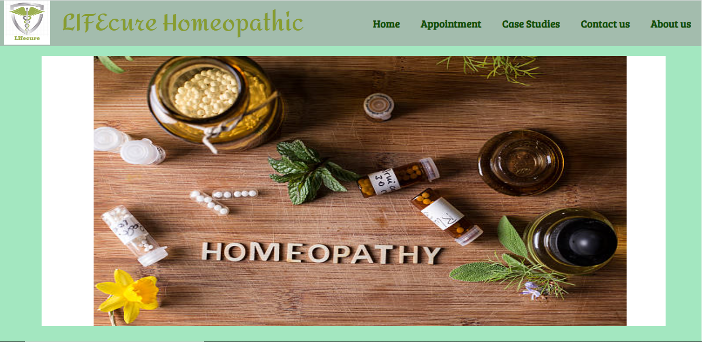

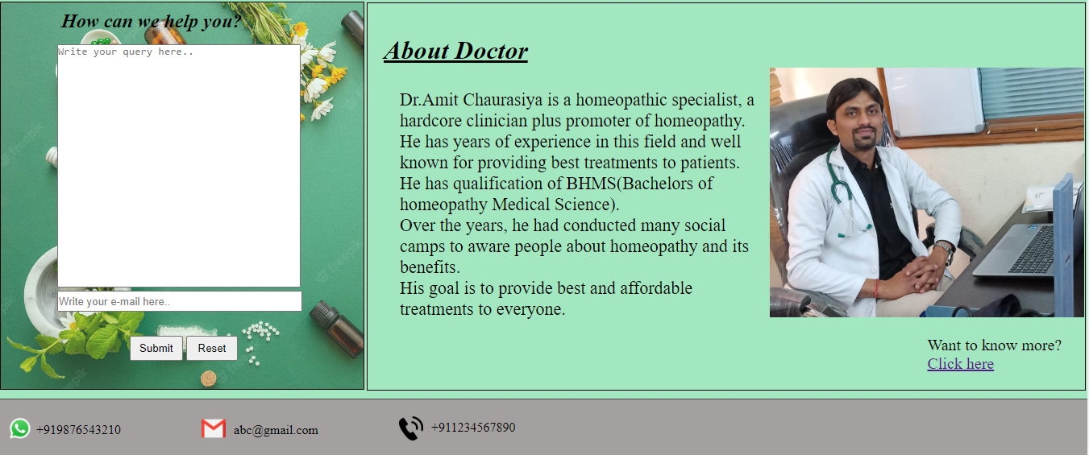

<!DOCTYPE html>

<html lang="en">

<head>

<meta charset="UTF-8">

<meta http-equiv="X-UA-Compatible" content="IE=edge">

<meta name="viewport" content="width=device-width, initial-scale=1.0">

<title>LIFEcure Clinic</title>

<link rel="stylesheet" href="Menu.css">

<link rel="stylesheet" href="Home.css">

<link rel="icon" href="logo.png">

<link href="https://unpkg.com/aos@2.3.1/dist/aos.css" rel="stylesheet">

<link href="https://fonts.googleapis.com/css2?family=Amita:wght@700&display=swap" rel="stylesheet">

<link href="https://fonts.googleapis.com/css2?family=Bree+Serif&display=swap" rel="stylesheet">

</head>

<body>

<header>

<navbar id="nav">

<div id="logo">

<img src="logo.PNG">

</div>

<div id="name">

LIFEcure Homeopathic

</div>

<ul>

<li><a href="Home.html">Home</a></li>

<li><a href="Appointment.html">Appointment</a></li>

<li><a href="Casestudy.html">Case Studies</a></li>

<li><a href="Contact.html">Contact us</a></li>

<li><a href="About.html">About us</a></li>

</ul>

</navbar>

</header>

<div class="frame">

<div class="images">

<div class="container">

<img src="Pic-1.jpg">

</div>

<div class="container">

<img src="Pic-3.jpg">

</div>

<div class="container">

<img src="Pic-2.jpg">

</div>

</div>

</div>

<div id="description" data-aos="zoom-in">

<span>Welcome to Lifecure </span>

<h2>What do you know about Homeopathy?</h2>

<h3>Let us explore little bit about Homeopathy....</h3>

<p>Homeopathic medicines are prepared from tiny amounts of proven healing

substances derived mainly from plants,minerals and animals.They are given in very

minute doses so that they are non-toxic,and are very safe.Unlike antibiotics and

other medicines.Homeopathic medicines will not hamper digestion,lower immune resistance

not produce allergic reactions and are safe in long term if taken as directed by a qualified

homeopath.

</p>

<p>

Homeopathy is effective and fast acting restoring optimal health.

Homeopathy prescribing is effective in both accute and chronic conditions.

</p>

<p>

Homeopathy is based on nature's principle of cure.Homeopathy has a long standing healing

tradition and is now the most popular holistic therapy worldwide.Homeopathic treatments addresses

disease at the root level,hence enhancing resistance to disease.

</p>

<p>Homeopathic medicines are safe for everyone because there is no risk of toxicity or

side effects.Homeopathy is ideal for all life stages.

</p>

</div>

<div class="query">

<form>

<h2>How can we help you?</h2>

<textarea placeholder="Write your query here.." required></textarea><br>

<input type="email" placeholder="Write your e-mail here.." id="input_mail" required><br>

<input type="submit" id="submit" class="button">

<input type="reset" value="Reset" id="reset" class="button">

</form>

</div>

<div id="about">

<h1>About Doctor</h1>

<div>Dr.Amit Chaurasiya is a homeopathic specialist, a hardcore clinician plus promoter of homeopathy. He has years of experience in this field and well known for providing best treatments to patients.

He has qualification of BHMS(Bachelors of homeopathy Medical Science).<br>Over the years, he had conducted many social camps to aware people about homeopathy and its benefits.

<br> His goal is to provide best and affordable treatments to everyone.

</div>

<p>

Want to know more? <a href="About.html">Click here</a>

</p>

<img id="doctorimg" src="Doctor.jpg">

</div>

<footer class="foot">

<a href="https://wa.me/919876543210" target="blank">

<img src="whatsapp.png" id="wplogo">

<p id="wp">+919876543210</p>

</a>

<a href="mailto:abc@gmail.com" target="blank">

<img src="mail.png" id="maillogo">

<p id="mail">abc@gmail.com</p>

</a>

<a href="tel:+911234567890" target="blank">

<img src="call_logo.png" id="call-logo">

<p id="call">+911234567890</p>

</a>

</footer>

<script src="https://unpkg.com/aos@2.3.1/dist/aos.js"></script>

<script>

AOS.init();

</script>

</body>

</html>

*{

margin: 0px;

padding: 0px;

}

#nav::before{

content:" ";

background-color:rgb(164, 160, 160);

position: absolute;

height: 88px;

width: 100%;

z-index: -1;

opacity: 0.6;

}

#nav{

display: flex;

align-items: center;

}

#logo img{

height:86px;

width:88px;

margin: -2px;

padding-left: 10px;

}

@keyframes identifier {

from{

width: 100px;

}

to{

width:1px;

}

}

#name{

color:rgb(135, 157, 48);

font-family: 'Amita', cursive;

font-weight: bolder;

font-size:45px;

margin-left: 25px;

}

#nav ul{

display: flex;

position: absolute;

RIGHT: 0%;

list-style: none;

margin-left: px;

}

#nav li{

font-size: 20px;

font-family: 'Playfair Display', serif;

font-weight: bolder;

padding: 20px;

}

#nav li a{

text-decoration: none;

color: rgb(16, 78, 3);

font-family: 'Bree Serif', serif;

}

#nav li a:hover{

background-color:rgb(133, 130, 130) ;

border-radius: 12px;

}

.foot{

border-top: 0.5px solid rgb(72, 71, 71);

margin-top: 10px;

height: 70px;

display: flex;

background-color:rgb(164, 160, 160);

}

#wplogo{

height:30px;

width: 30px;

margin-left: 10px;

margin-top: 21px;

}

#maillogo{

height:30px;

width: 30px;

margin-left: 100px;

margin-top: 21px;

}

#call-logo{

height:30px;

width: 30px;

margin-left: 100px;

margin-top: 21px;

}

.foot a{

text-decoration: none;

}

#wp{

margin-left: 45px;

margin-top: -26px;

color:black;

}

#mail{

margin-left: 140px;

margin-top: -26px;

color:black;

}

#call{

margin-left: 140px ;

margin-top: -29px;

color: black;

}

#wp:hover{

box-shadow: 1px 1px 2px 2px rgb(46, 46, 46);

}

#mail:hover{

box-shadow: 1px 1px 2px 2px rgb(46, 46, 46);

}

#call:hover{

box-shadow: 1px 1px 2px 2px rgb(46, 46, 46);

}

.frame{

overflow: hidden;

height:520px;

width:1200px;

margin-top: 20px;

margin-left: 80px;

background-color: white;

}

@keyframes slide_animation{

10%{

left:0;

}

25%{

left:-1200px;

}

50%{

left:-2400px;

}

75%{

left:-1200px;

}

100%{

left:0px;

}

}

.images{

width:3600px;

height:800px;

margin-left: 100px;

margin-right: 0px;

position: relative;

animation-name: slide_animation;

animation-duration: 50s;

animation-iteration-count:infinite;

animation-direction:alternate ;

animation-play-state: running;

background-color: white;

}

.container{

height:800px;

width:1200px;

position: relative;

float: left;

}

.container img{

height:80vh;

width:75vw;

}

#description {

background-image :url("Desc_img.jpg");

background-size:100% 100vh;

background-repeat: no-repeat;

height: 400px;

width:98.7%;

border: 9px solid rgb(113,213,201);

border-radius: 5px;

margin-top: 30px;

position: relative;

float: left;

}

#description span{

color:rgb(24,82,77);

font-weight: bold;

font-size: 50px;

animation-name: welcome;

animation-delay: 3s;

animation-duration:7s;

animation-iteration-count:1;

visibility: hidden;

animation-fill-mode: forwards;

}

@keyframes welcome{

from{

margin-left:67%;

width:70%;

opacity: 0;

visibility: visible;

}

to{

margin-left:0% ;

width: 0%;

opacity: 1;

visibility: visible;

}

}

#description h2{

margin-top: 30px;

color: rgb(7, 7, 76);

animation-name:H2;

animation-delay:7s;

animation-duration:5s;

animation-iteration-count:1;

visibility: hidden;

animation-fill-mode: forwards;

}

@keyframes H2{

from{

margin-left:67%;

width:70%;

opacity: 0;

visibility: visible;

}

to{

margin-left:2% ;

width: 70%;

opacity:1;

visibility: visible;

}

}

#description h3{

margin-top: 15px;

margin-left: 27px;

color: rgb(7, 7, 76);

animation-name:H3;

animation-delay:12s;

animation-duration:5s;

animation-iteration-count:1;

visibility: hidden;

animation-fill-mode: forwards;

}

@keyframes H3{

from{

margin-left:67%;

width:70%;

opacity: 0;

visibility: visible;

}

to{

margin-left:4% ;

width: 70%;

opacity: 1;

visibility: visible;

}

}

#description p{

margin-top: 20px;

font-size: 20px;

margin-left: 47px;

font-style: italic;

animation-name:Description;

animation-delay:17s;

animation-duration:5s;

animation-iteration-count:1;

visibility: hidden;

animation-fill-mode: forwards;

}

@keyframes Description{

from{

margin-left:67%;

width:90%;

opacity: 0;

visibility: visible;

}

to{

margin-left:6% ;

width: 94%;

opacity: 1;

visibility: visible;

}

}

.query::before{

content:" ";

background-image:url("query.jpg");

background-size: cover;

background-repeat: no-repeat;

position:absolute;

width:450px;

height:480px;

z-index: -1;

opacity: 0.8;

}

.query{

display: flex;

margin-top: 450px;

border:1px solid black;

width:450px;

height:480px;

}

.query textarea{

margin-top: 15px;

margin-left:70px;

height: 300px;

width:300px;

resize: none;

}

.query h2{

text-align: center;

color:black;

font-weight: bolder;

font-style: italic;

margin-top: 10px;

}

#input_mail{

width:300px;

height: 22px;

margin-left: 70px;

margin-bottom: 30px;

}

#submit{

margin-left: 160px;

padding: 6px 10px;

}

#reset{

padding: 6px 13px;

}

.button:hover{

background-color: rgb(144, 137, 137);

box-shadow: 0px 3px 3px 0px lightgray;

}

#about{

margin-top: -481.5px;

margin-left: 455px;

border: 1px solid black;

height:480px ;

width: 66%;

display:grid;

}

#about h1{

margin-left: 20px;

margin-top: 40px;

font-style: italic;

text-decoration: underline;

}

#doctorimg{

position: relative;

left:56%;

bottom:122%;

width: 390px;

height: 310px;

}

#about div{

width:50%;

font-size:22px;

margin-top: 30px;

margin-left: 40px;

}

#about p{

font-size: 20px;

margin-top: 20px;

margin-left: 78%;

}

**APPOINTEMENT PAGE-**

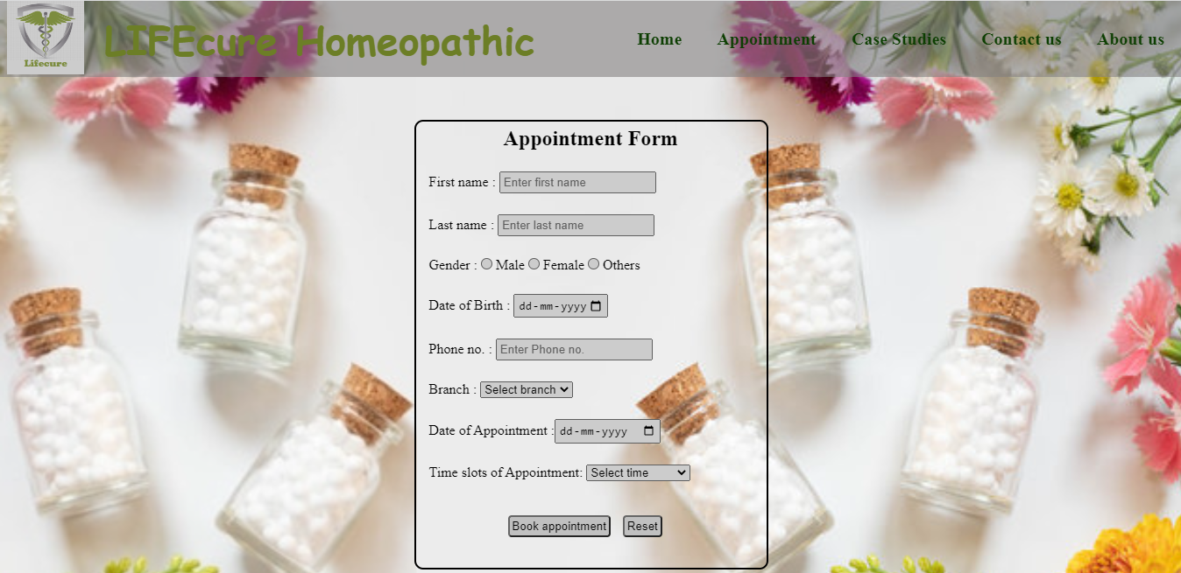

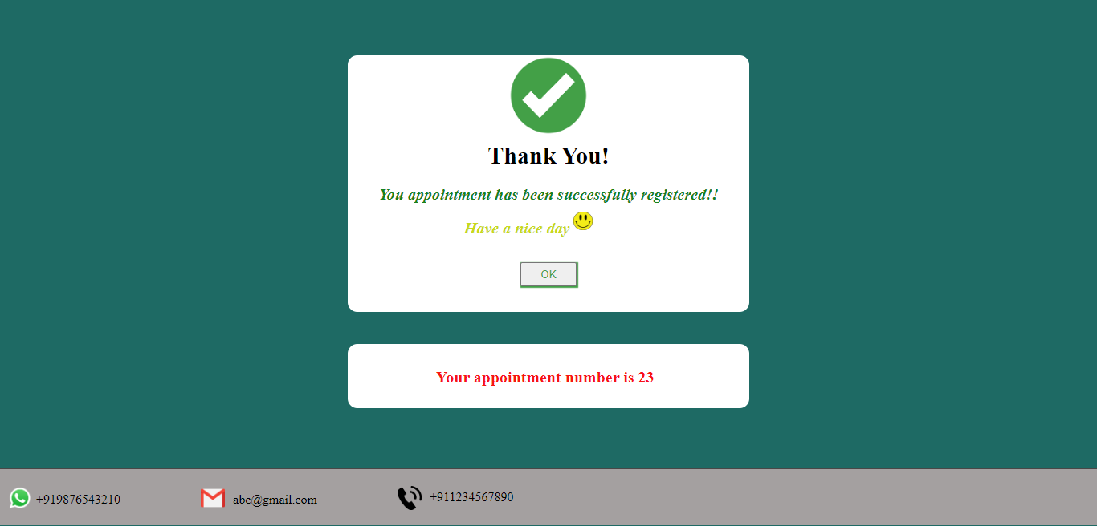

<!DOCTYPE html>

<html lang="en">

<head>

<meta charset="UTF-8">

<meta http-equiv="X-UA-Compatible" content="IE=edge">

<meta name="viewport" content="width=device-width, initial-scale=1.0">

<title>Book your Appointment</title>

<link rel="stylesheet" href="Menu.css">

<link rel="stylesheet" href="Appointment.css">

<link rel="icon" href="logo.png">

</head>

<body>

<div id="appointment">

<form action="Login.html">

<h2>Appointment Form</h2>

<div>

First name : <input type="text" placeholder="Enter first name" required>

</div>

<div>

Last name : <input type="text" placeholder="Enter last name" required>

</div>

<div>

Gender : <input type="radio" name="select" value="Male" required> Male

<input type="radio" name="select" value="Female"> Female

<input type="radio" name="select" value="Others"> Others

</div>

<div>

Date of Birth : <input type="date" id="dob" required>

</div>

<div>

Phone no. : <input type="text" maxlength="10"

placeholder="Enter Phone no." required>

</div>

<div>

Branch : <select required>

<option selected hidden>Select branch</option>

<option >Kanpur</option>

<option >Fatehpur</option>

</select>

</div>

<div>

Date of Appointment :<input type="date" id="Adate" required>

</div>

<div>

Time slots of Appointment: <select required>

<option selected hidden>Select time</option>

<option>10 A.M - 12 P.M</option>

<option>2 P.M - 5 P.M</option>

<option>7 P.M - 9 P.M</option>

</select>

</div>

<div>

<input id="sub" type="submit" value="Book appointment">

<input type="Reset" id="reset">

</div>

</form>

<script>

current_date=new Date();

var date=current_date.getDate();

var month=current_date.getMonth()+1;

var year=current_date.getFullYear();

if(date<10){

date='0'+date;

}

if(month<10){

month='0'+month;

}

var min_Date=year+ "-" +month+ "-" +date;

document.getElementById("Adate").setAttribute('min',min_Date);

document.getElementById("dob").setAttribute('max',min_Date);

</script>

</div>

</body>

</html>

<!DOCTYPE html>

<html lang="en">

<head>

<meta charset="UTF-8">

<meta http-equiv="X-UA-Compatible" content="IE=edge">

<meta name="viewport" content="width=device-width, initial-scale=1.0">

<title>Appointment registered</title>

<link rel="stylesheet" href="Menu.css">

<link rel="stylesheet" href="Login.css">

<link rel="icon" href="logo.png">

</head>

<body>

<div id="popup">

<img src="tick.png">

<h2>Thank You!</h2>

<p id="p1">You appointment has been successfully registered!!</p>

<p id="p2">Have a nice day

<img src="smiley.jpg">

</p>

<a href="Home.html"><button type="button">OK</button></a>

</div>

<div class="popup1">

<p id="appointmentid"></p>

</div>

<script>

var element=document.getElementById('appointmentid');

var max=30;

var min=1;

var id=Math.floor(Math.random()*(max-min+1))+min;

element.innerHTML="Your appointment number is "+id;

</script>

</body>

</html>

**CASE STUDIES PAGE-**

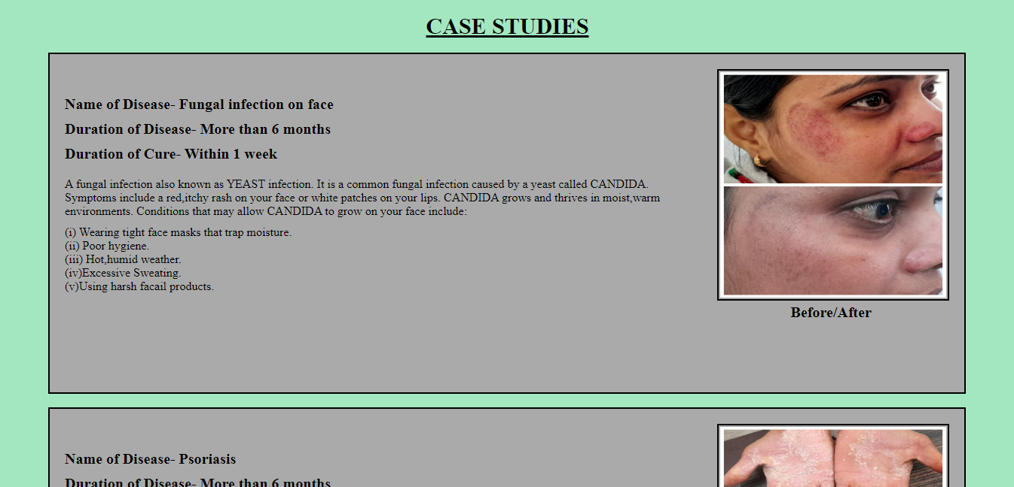

<!DOCTYPE html>

<html lang="en">

<head>

<meta charset="UTF-8">

<meta http-equiv="X-UA-Compatible" content="IE=edge">

<meta name="viewport" content="width=device-width, initial-scale=1.0">

<title>Case Study</title>

<link rel="stylesheet" href="Menu.css">

<link rel="stylesheet" href="Home.css">

<link rel="stylesheet" href="Casestudy.css">

<link rel="icon" href="logo.png">

</head>

<body>

<h1>CASE STUDIES</h1>

<div class="Case">

<img src="Case-1.jpg">

<p id="before">Before/After</p>

<p id="head"> Name of Disease- Fungal infection on face</p>

<p id="head1">Duration of Disease- More than 6 months</p>

<p id="head2">Duration of Cure- Within 1 week</p>

<p id="descrp">

A fungal infection also known as YEAST infection. It is a common fungal infection caused by a yeast

called CANDIDA. Symptoms include a red,itchy rash on your face or white patches on your lips.

CANDIDA grows and thrives in moist,warm environments. Conditions that may allow CANDIDA to grow on

your face include:

</p>

<p id="points">

(i) Wearing tight face masks that trap moisture.<br>

(ii) Poor hygiene.<br>

(iii) Hot,humid weather.<br>

(iv)Excessive Sweating.<br>

(v)Using harsh facail products.

</p>

</div>

<div class="Case">

<img src="Case-2.jpg">

<p id="before">Before/After</p>

<p id="head"> Name of Disease- Psoriasis</p>

<p id="head1">Duration of Disease- More than 6 months</p>

<p id="head2">Duration of Cure- 1 Month</p>

<p id="descrp">

Psoriasis is a common long-term(chronic) disease with no cure. It can be painful, interfere with sleep

and make it hard to concentrate. Many peple who are predisposed to psoriasis may be free of symptoms

for years until te disease is triggered by some environmental factor. Common psoriasis triggers include:

</p>

<p id="points">

(i) Smoking and exposure to secondhand smoke.<br>

(ii) Heavy alcohol consumption.<br>

(iii) Rapid withdrawal of oral or injected corticosteroids.<br>

(iv) Certain medications-including lithium,high blood pressure drugs and antimalarial drugs.<br>

(v) Injury to the skin, such as cut or scrape, a bug bite, or a severe sunburn.

</p>

</div>

<div class="Case">

<img src="Case-3.jpg">

<p id="before">Before/After</p>

<p id="head"> Name of Disease- Tinea</p>

<p id="head1">Duration of Disease- More than 6 months</p>

<p id="head2">Duration of Cure- 15 days</p>

<p id="descrp">

Tinea is also known as ringworms. This is because it can cause red patches on the skin in th shape of

rings. But it's not caused by worms. It's caused by different types of fungi. Tinea infections of the feet,

nails and genital area are not often called ringworms. This is because the red patches may not look like

rings. The fungus that causes tinea is very common all over the world, including the U.S. It's very contagious.

The fungus is spread through direct contact with:

</p>

<p id="points">

(i) An infected person.<br>

(ii) Infected objects such as towels, clothing, and combs.<br>

(iii) An infected animal.<br>

(iv) Infected soil.<br>

It can take days or upto 2 weeks before you develop the infection after being in contact with the fungus.

The fungi that cause ringworm can live for a long time on objects. Because of this, you may not know

the exact source.

</p>

</div>

<div class="Case">

<img src="Case-4.jpg">

<p id="before">Before/After</p>

<p id="head"> Name of Disease- Psoriasis(Scalp)</p>

<p id="head1">Duration of Disease- More than 2 years</p>

<p id="head2">Duration of Cure- 3 Months</p>

<p id="descrp">

Psoriasis is a common long-term(chronic) disease with no cure. It can be painful, interfere with sleep

and make it hard to concentrate. Many peple who are predisposed to psoriasis may be free of symptoms

for years until te disease is triggered by some environmental factor. Common psoriasis triggers include:

</p>

<p id="points">

(i) Smoking and exposure to secondhand smoke.<br>

(ii) Heavy alcohol consumption.<br>

(iii) Rapid withdrawal of oral or injected corticosteroids.<br>

(iv) Certain medications-including lithium,high blood pressure drugs and antimalarial drugs.<br>

(v) Injury to the skin, such as cut or scrape, a bug bite, or a severe sunburn.

</p>

</div>

</body>

</html>

**CONTACT US PAGE-**

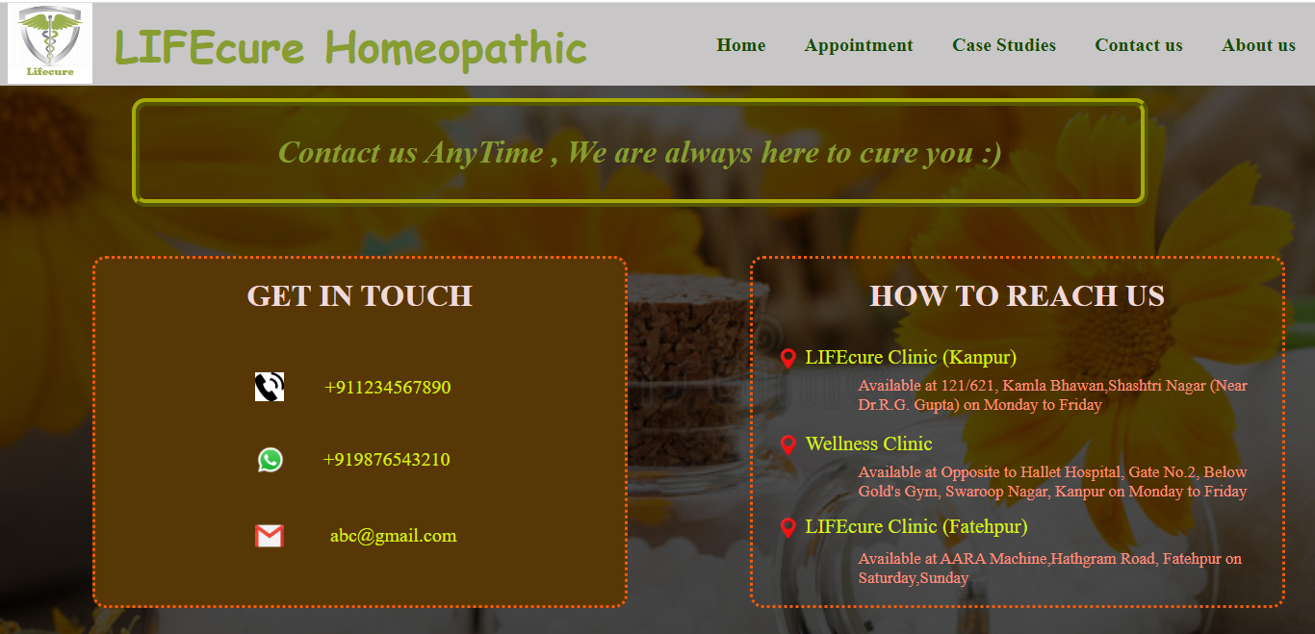

<!DOCTYPE html>

<html lang="en">

<head>

<meta charset="UTF-8">

<meta http-equiv="X-UA-Compatible" content="IE=edge">

<meta name="viewport" content="width=device-width, initial-scale=1.0">

<title>Contact Us</title>

<link rel="stylesheet" href="Menu.css">

<link rel="stylesheet" href="Contact.css">

<link rel="icon" href="logo.png">

</head>

<body>

<div id="backimg"></div>

<div class="details">

Contact us AnyTime , We are always here to cure you&nbsp;:)

</div>

<div class="getintouch">

<h1>GET IN TOUCH</h1>

<span>

<a href="tel:+911234567890" target="blank">

<img src="call_logo.png" id="call-logo">

<p id="call">+911234567890</p></a>

</span>

<span>

<a href="https://wa.me/919876543210" target="blank">

<img src="whatsapp.png" id="wplogo">

<p id="wp">+919876543210</p> </a>

</span>

<span>

<a href="mailto:abc@gmail.com" target="blank">

<img src="mail.png" id="maillogo">

<p id="mail">abc@gmail.com</p>

</a>

</span>

</div>

<div class="address">

<h1>HOW TO REACH US</h1>

<span>

<a type="button" onclick="LCK()">

<img src="location.png" id="locationlogo1">

<p id="LC_K">LIFEcure Clinic (Kanpur) </p>

<p id="lck"></p>

</a>

</span>

<span>

<a type="button" onclick="WCK()">

<img src="location.png" id="locationlogo2">

<p id="WC_K">Wellness Clinic</p>

<p id="wck"></p>

</a>

</span>

<span>

<a type="button" onclick="LCF()">

<img src="location.png" id="locationlogo3">

<p id="LC_F">LIFEcure Clinic (Fatehpur)</p>

<p id="lcf"></p>

</a>

</span>

</div>

</body>

<script>

function LCK(){

document.getElementById('lck').innerHTML=

"Available at 121/621, Kamla Bhawan,Shashtri Nagar (Near Dr.R.G. Gupta) on Monday to Friday";

}

function WCK(){

document.getElementById('wck').innerHTML=

"Available at Opposite to Hallet Hospital, Gate No.2, Below Gold's Gym, Swaroop Nagar, Kanpur on Monday to Friday";

}

function LCF(){

document.getElementById('lcf').innerHTML=

"Available at AARA Machine,Hathgram Road, Fatehpur on Saturday,Sunday";

}

</script>

</html>

**ABOUT US PAGE-**

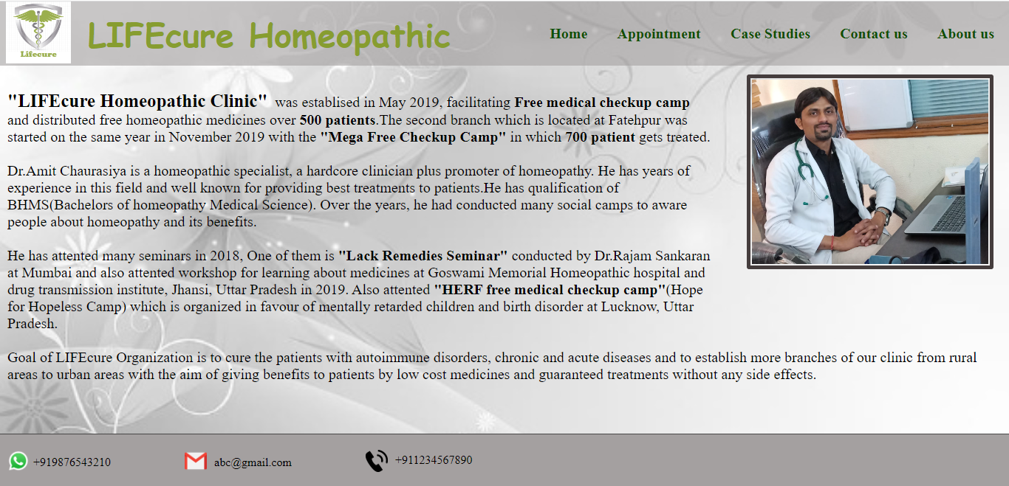

<!DOCTYPE html>

<html lang="en">

<head>

<meta charset="UTF-8">

<meta http-equiv="X-UA-Compatible" content="IE=edge">

<meta name="viewport" content="width=device-width, initial-scale=1.0">

<title>About Us</title>

<link rel="stylesheet" href="About.css">

<link rel="stylesheet" href="Menu.css">

<link rel="icon" href="logo.png">

</head>

<body>

<div id="doctorimg">

<img src="Doctor.jpg">

</div>

<div>

<p id="history">

<strong style="font-size: 25px;">"LIFEcure Homeopathic Clinic"</strong>&nbsp; was establised in May 2019, facilitating <strong>Free medical checkup camp </strong>

and distributed free homeopathic medicines over <span style="font-weight:600;">500 patients</span>.The second branch which

is located at Fatehpur was started on the same year in November 2019 with the <strong>"Mega Free Checkup Camp"</strong> in which <span style="font-weight:600;">700 patient</span>

gets treated.

</p>

<p id="intro">

Dr.Amit Chaurasiya is a homeopathic specialist, a hardcore clinician plus promoter of homeopathy. He has years

of experience in this field and well known for providing best treatments to patients.He has qualification of BHMS(Bachelors of homeopathy Medical Science).

Over the years, he had conducted many social camps to aware people about homeopathy and

its benefits.

</p>

<p id="knowledge">

He has attented many seminars in 2018, One of them is <strong>"Lack Remedies Seminar"</strong> conducted

by Dr.Rajam Sankaran at Mumbai and also attented workshop for learning about medicines

at Goswami Memorial Homeopathic hospital and drug transmission institute, Jhansi, Uttar Pradesh in 2019.

Also attented <strong>"HERF free medical checkup camp"</strong>(Hope for Hopeless Camp)

which is organized in favour of mentally retarded children and birth disorder at Lucknow, Uttar Pradesh.

</p>

<p id="goals">

Goal of LIFEcure Organization is to cure the patients with autoimmune disorders,

chronic and acute diseases and to establish more branches of our clinic from rural areas

to urban areas with the aim of giving benefits to patients by low cost medicines and guaranteed

treatments without any side effects.

</p>

</div>

</body>

</html>

**FUTURE SCOPE**

* It will facilitates the patients with **Online Consultant** of the doctor.
* **Home delivery** of medicines will be provided.
* Patients will also get **Online prescription** facility. This intuitive features enables doctors to aware patients about checkups and medicines.
* It facilitates the doctor to regulate and expand the span of preventive medicine, primary healthcare and wellness program beyond conventional boundaries.
* The Doctor can easily retrieve the data of their patients.
* Diet to follow in particular disease can be accessed by patients.
* Services and Solution can prove to be a game changer in patient’s care space.
* It will maximize the care delivery for the consumer.

**CONCLUSION**

LIFEcure Clinic management System is all about modernizing the clinic through the use of technology. Computers help in it and take over the manual system for quick, easy and reliable functioning. Clinic management by manual way is tedious process, since it involves work load and time consumption.

In this system, we can easily manage the clinic. All the basic requirements of the clinic are provided which is necessary to manage the clinic. It gives many facilities like booking an appointment, asking query to doctor, get details about the diseases cured by the doctor itself, checking the availability of doctor and also the location and time in which the doctor serves.

We will improve the project in future in terms of security, database and with much more functionalities.

We are waiting for your best suggestion and encouragement which could make us improve the future programming much better than the one we carried out.

**BIBLIOGRAPHY**

These resources are referred during the development of this project-

* <https://www.lifeforce.in/>
* <https://www.w3schools.com/>
* <https://stackoverflow.com/>
* <https://www.geeksforgeeks.org/>
* <https://www.youtube.com/>
* <https://www.html.com/>
* <https://www.tutorialspoint.com/>
* <https://michalsnik.github.io/aos/>